

Mobile app project report



Project Name:

Admission Informer App

Submitted by:

Name: Md.Habibur Rahman

Roll: 40

Admission Informer App

# **Project Description:**

The admission informer app is developed for the purpose of providing authentic University Admission Test Information of Bangladesh. Every year thousands of students take part in admission test in Bangladesh to get themselves admitted. For this, they need all the information regarding the university but as most of the students don't know from where they can get the informations or sometimes they really find it difficult to search universities all the time because they have to browse every particular university daily which is really time consuming. As a helping hand, Admission aid app will provide all the necessary informations of university admission like admission circular,application,criteria,procedure, deadline,fees,admit card details,result etc.This app will also provide information through notifications so that students don't have to search daily.I have a vision to connect the large number of students through this initiative and it will be continued.

The app is built using android studio the most popular and google approved IDE.It is primarily developed for the android OS using Java language and it will also be available for the IOS platform in the near future.So stay tune.

Diving into coding

It required almost 12/14 Activities apart from their xml files,drawable folders,package classes to develop the app.Screenshots of these files are given below:

SplashScreenActivity and Xml File:

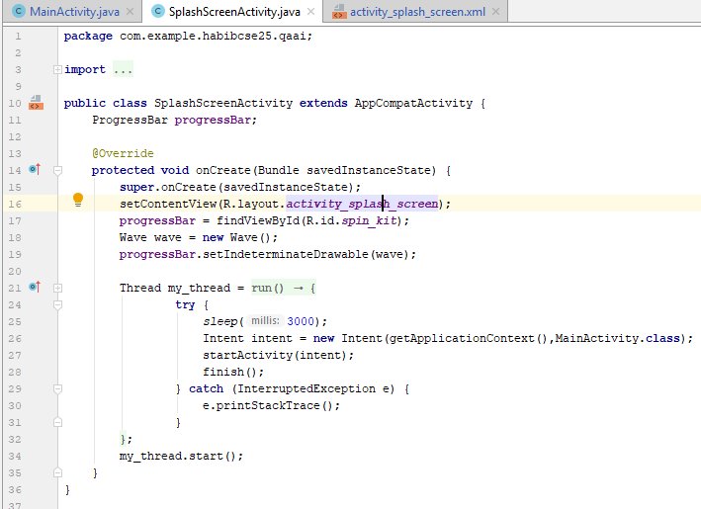

SplashScreen Xml file:

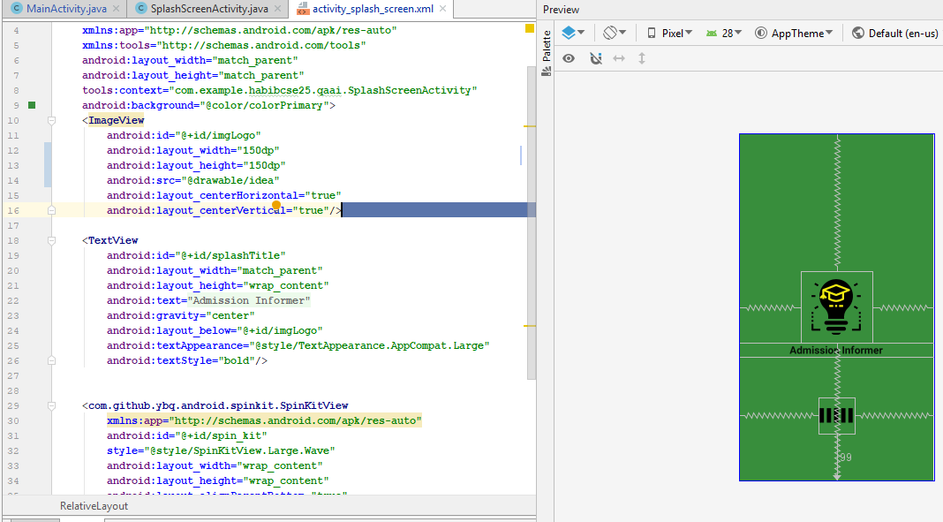

MainActivity.java(part1)

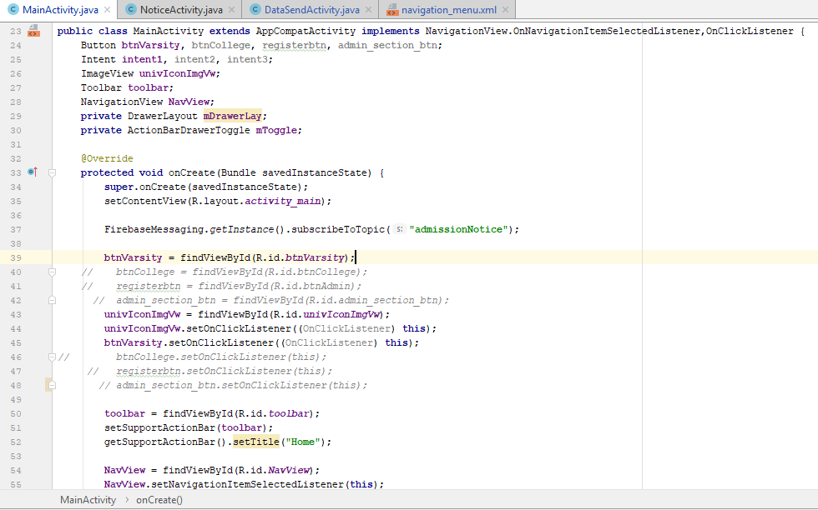

MainActivity.java(part2 and part3)

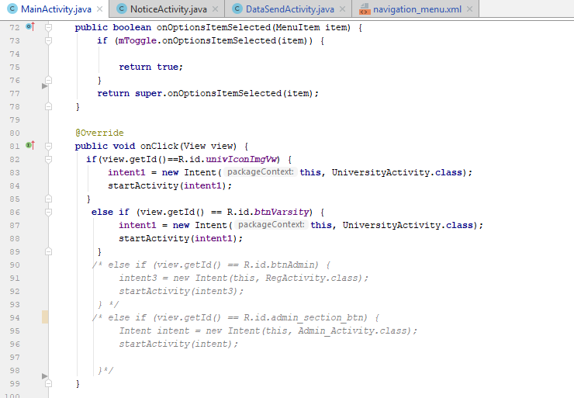

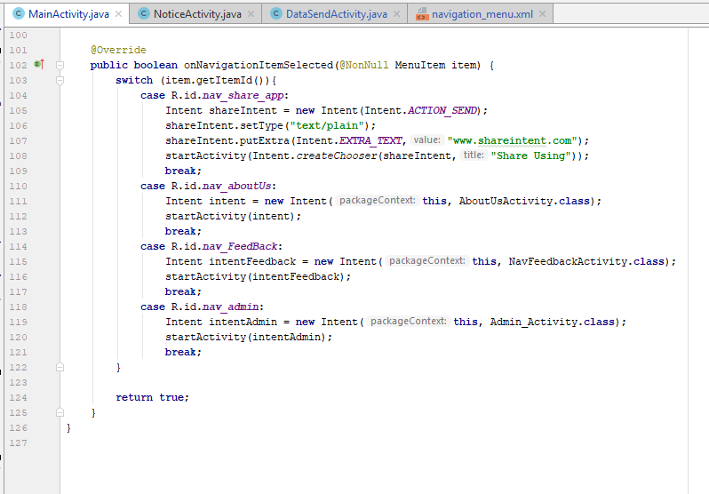

PrivateUniversityActivity and xml file

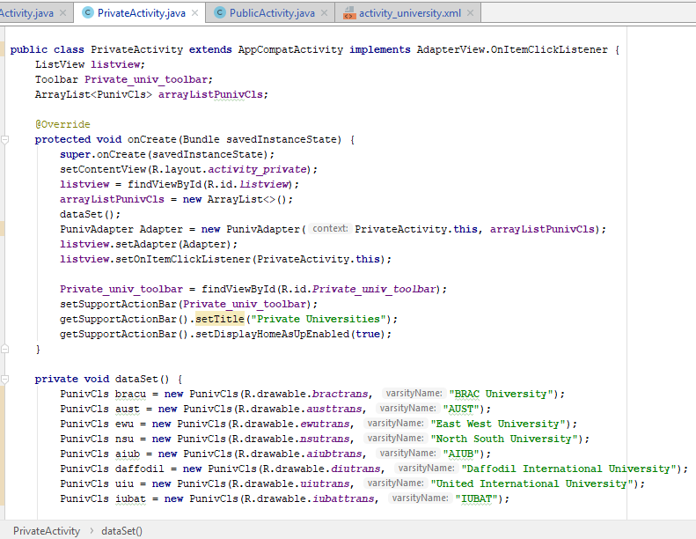

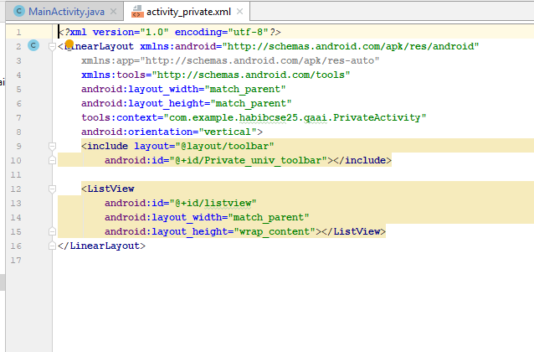

PrivateUniversityActivity and xml file

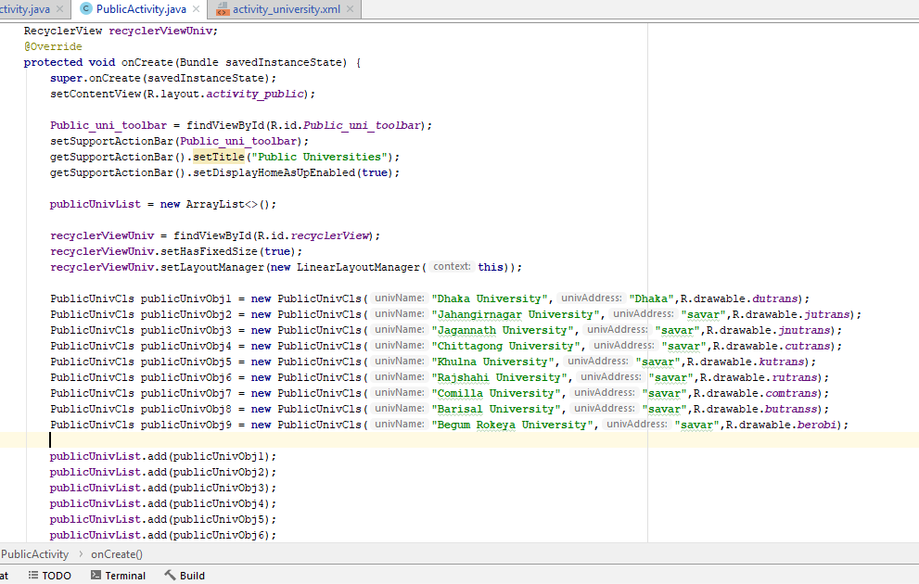

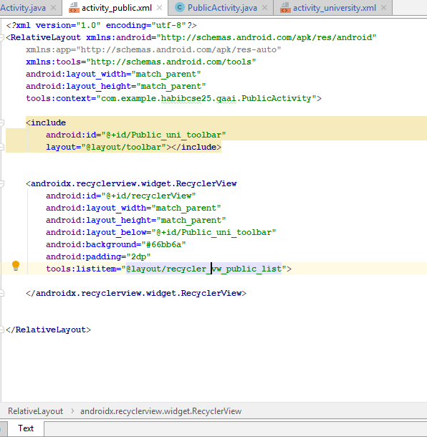

EngineeringUniversityActivity and xml file

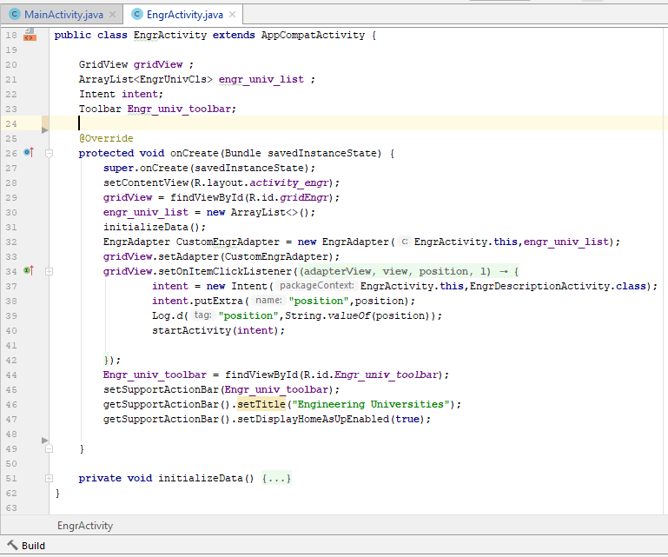

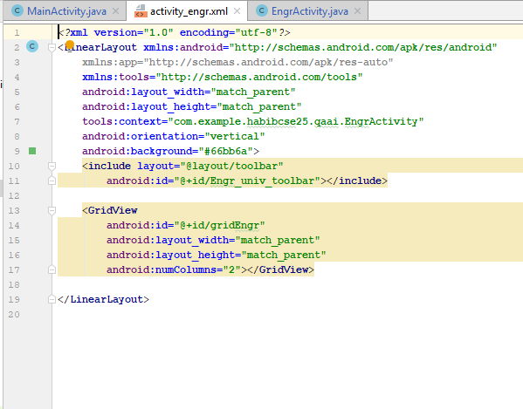

UniversityActivity and xml File:

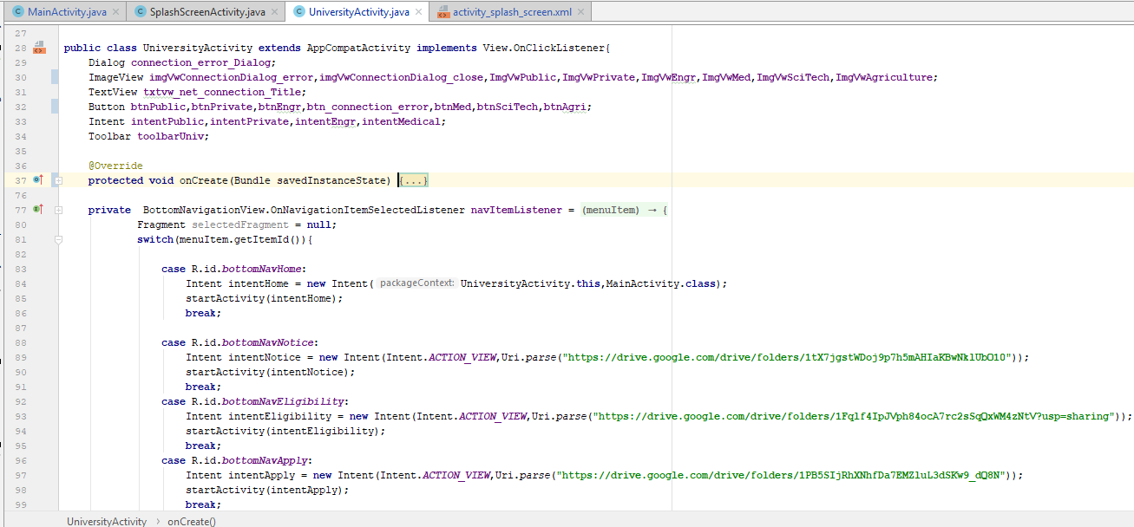

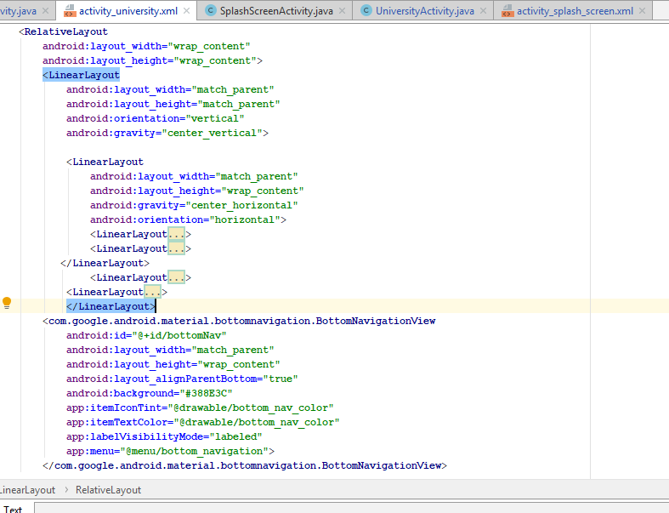

DataSendActivity

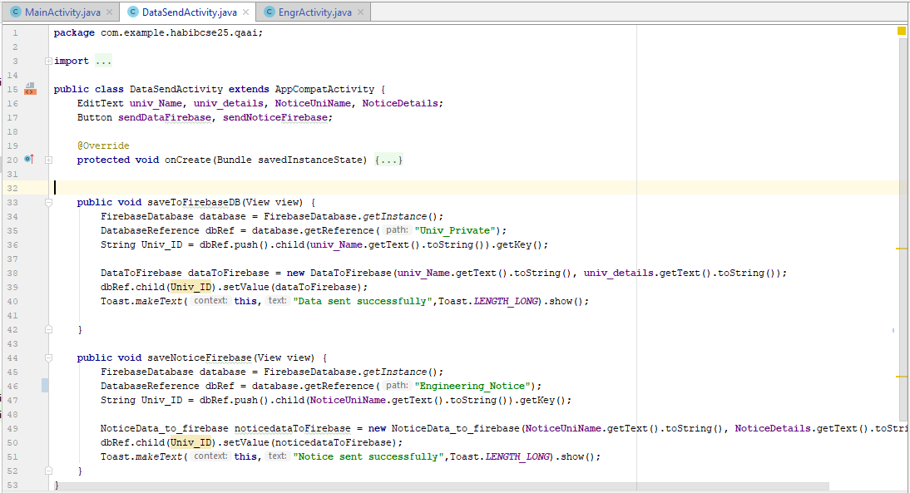

Travelling into App Feature

**Opening of App**

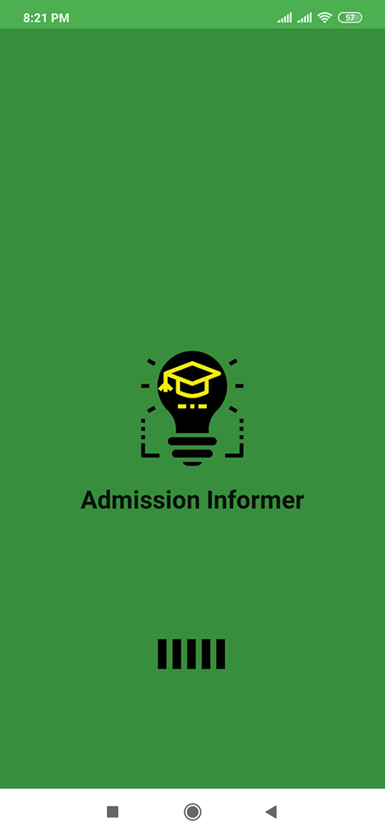

|  |  |  |
| --- | --- | --- |
|  |  |  |

|  |  |  |
| --- | --- | --- |
|  |  |  |

|  |  |
| --- | --- |
|  |  |

|  |  |  |
| --- | --- | --- |
|  |  |  |

|  |
| --- |
|  |
|  |
|  |

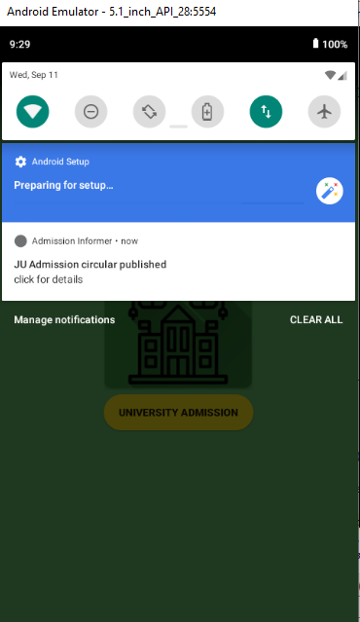

Firebase Database

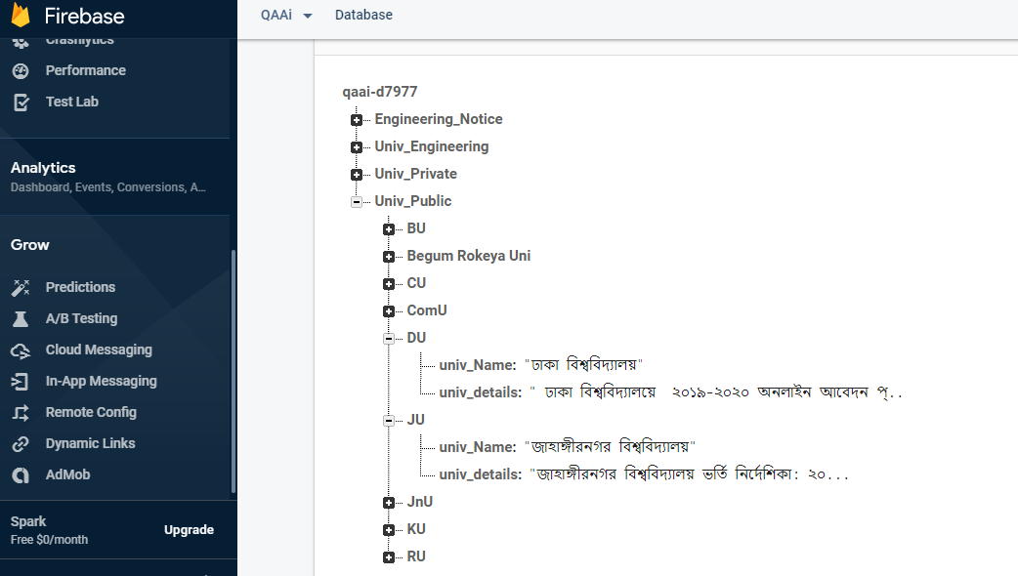

The screencast of the app is also available in the following drive link-

https://drive.google.com/drive/folders/1-Brdz_urv8vkhjpHtEiir0psPArvXkyF?fbclid=IwAR2TWnN7tuIQTTYqNfwRbiMoUOpTJhLzbA9zo8c4ioGTaPa3boCAMr7v1ys